ESCOLA ________________________________________DATA:_____/_____/_____ PROF:______________________________________________TURMA:___________
NOME:_______________________________________________________________


1.Analise o texto abaixo e retire todos os verbos regulares ( regular verbs). Escrevaos nas caixas de texto ao lado. Visited, walked, traveled, arrived, watched
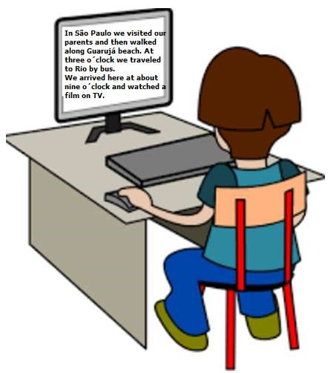

2.Preencha as lacunas das frases com “regular verbs”.
a.I____________a good film yesterday.( to watch) watched
b.He ___________her friends last weekend. ( to visit) visited
c.They __________the violin at the party. ( to play) played
d.They_____________hard last month.(to work) worked
e.You______________your living room very well!( to clean) cleaned

f.In the afternoon I ____________________along a lake. (to walk) walked
g.My cousin _____________the piano and I ____________the drinks.( to play/to prepare) played/prepared
h.In the morning I _____________the birds and the sunset.( to watch) watched
I.On weekends we_______________parties.( to organize)organized

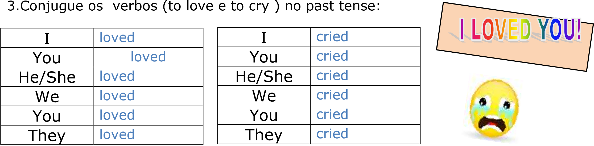
4.Reescreva o texto abaixo substituindo os verbos grifados pelo passado. Também substitua a expressão every day por yesterday. Obs:Letra legível) arrived, worked,returned, helped, talked, watched

Kevin arrives in his office at seven o´clock every day.

He works from seven o´clock a.m.

to four o´clock p.m. and then he returns home. He helps his wife in the kitchen and after dinner they talk and watch TV programs.

__________________________
__________________________
__________________________
__________________________
__________________________
__________________________
__________________________
5..Complete as sentenças com o ”Simple Past Tense” dos verbos regulares, em seguida, assinale na alternativa correta. I ________my friend yesterday. ( to visit)
a.( )visited b.( ) visitied
They_________a new restaurant last week. ( to open)
a.( ) opened b.( ) oppened
The little boy_________your question. ( to answer)
a.( ) answered b.( ) answerred
Jonas________very well yesterday. ( to dance)

a.( ) danced b.( ) danceed
The children___________the new recreation center last week.(to visit)
a.( )visited b.( ) visitied
You_________computer games yesterday. ( to play)
a.( ) played b.( ) plaied
We________the new coffee shop.( to love)
a.( )loved b.( ) loveed
My father ____________Canada at university. ( to study)
a.( )studyed b.( ) studied
6.Complete a cruzadinha com os verbos regulares no passado em inglês.
