**Atividades Escolares**

**2° ano do Ensino Médio**

|  |  |
| --- | --- |
| **Língua Inglesa** | |
| Códigos das Habilidades | Objetos de conhecimentos |
| EM13LGG403 | -Leitura e interpretação de um texto narrativo;  -Estrutura de um texto Narrativo;  - Possessive adjectives and pronouns. |

**ESCOLA ESTADUAL RUI BARBOSA**

___________________________________________________________________________

Nome do Professor

___________________________________________________________________________

Nome do Estudante

___________________________________________________________________________

Período: ( ) vespertino ( ) matutino Turma 2º ano _____

**Aula 01**

**Texto narrativo: estrutura e elementos da narrativa**

Texto narrativo é caracterizado por narrar uma história, ou seja, contar uma história através de uma sequência de várias ações reais ou imaginárias. Essa sucessão de acontecimentos é contada por um narrador e está estruturada em introdução, desenvolvimento e conclusão. Ao longo dessa estrutura narrativa são apresentados os principais elementos da narração: espaço, tempo, personagem, enredo e narrador.

https://www.normaculta.com.br/texto-narrativo/

READING:

Observe os textos Narrativos e sua estrutura.



1. **Elza Soares, 85, cantora que lançou “A Mulher do Fim do Mundo”**

“I was a child, I wasn't even ten years old, but I was already helping my mother, who was washing clothes outside. As was common at that time [early 1940s], we couldn't use the building's social elevator, only the service elevator. A stupid thing. But that day, which I never forgot, the service elevator was failing. With a bundle of clothes in my arms, my mother did not see that the cabin was on another floor when she opened the door and smashed into the ditch. It was an inhumane scene. The porter didn't warn us about the defect, nor did he let us use the social elevator. Employees, almost always black, could not. My mother was hurt a lot, but even so, nobody was sympathetic to her. He had to go out the back, so as not to disturb the residents. It was only many years later, as an adult, that I managed to process this image. I knew what racism was, but I didn't suspect that I could take on that dimension. It is a disease that continues today. And for which, unfortunately, there is no vaccine. ”

1. **Nayce Samara, 22, modelo que relatou seu caso de racismo no Facebook.**

“I was returning home after a parade and, inside the bus, which was going to Celândia [Brasília's satellite city], there were two ladies sitting. I was standing beside them, wearing a turban, which I usually wear a lot. As they whispered about me, I tried to listen. They said I was pretty, but with that handkerchief to cover my bad hair, I was ugly. I was very sad and angry too, demoted, disgusted, but I could only tell them how bad their prejudice was, not my hair. They were embarrassed and tried to explain themselves, but I said it was not necessary. As I was already close to my stop, I went to the back of the bus and swallowed. Racism is daily, common. It is bad to survive day by day in this sick, racist, homophobic, sexist and prejudiced society. But staying silent, for me, is no longer an option. Enough. ”

1. **Fabiana Moraes, 41, jornalista e socióloga, autora do livro “No país do racismo institucional”**

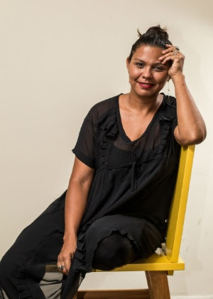

“I was the first person in my family to enter a university. In my class of 40 students I was one of the two black women. It was precisely from that place that I began to perceive more clearly the looks that were based on the color of my skin. I started to be treated as 'nega', which did not happen in Alto José Bonifácio [neighborhood on the outskirts of Recife], where my father still lives. I started interning in the seventh period of the journalism course at UFPE (Federal University of Pernambuco) in a newspaper. I was in the place I wanted, starting to do what I wanted: writing about the city, about culture, about politics. Later I was hired. Then a colleague came to congratulate me and said that it was really cool that I got a job in a prestigious place. He told me: ‘A classmate said that interning at the newspaper would be the most you could get in life’. This person's explanation is that I ‘had no basis’ for more. That hurt me a lot. And I am sure that this comment would not be aimed at someone who came from a famous school, someone white, with a known surname. ”

(Colaborou Cristiane Capuchinho)

FONTE: https://noticias.bol.uol.com.br/ultimas-noticias/brasil/2015/11/19/me-colocaram-numa-mesa-chamada-navio-negreiro-veja-5-relatos-de-racismo.htm

20 de novembro de 2015 / Sem categoria

**Answer ( Responda de acordo com as 3 narrativas)**

1. Quando aconteceu? (tempo)
2. __________________________________________________________________
3. __________________________________________________________________
4. __________________________________________________________________
5. Quem estava presente? (personagens)
6. __________________________________________________________________
7. __________________________________________________________________
8. __________________________________________________________________
9. Onde os personagens estavam? (espaço)

1-___________________________________________________________________

2-___________________________________________________________________

3-___________________________________________________________________

1. O que aconteceu? (enredo/introdução)

1-___________________________________________________________________

2-___________________________________________________________________

3-___________________________________________________________________

1. Como isso aconteceu? (desenvolvimento e conclusão)

1-___________________________________________________________________

2-___________________________________________________________________

3-___________________________________________________________________

2) Faça um texto narrativo curto (em inglês) de algum acontecimento que marcou na sua vida.

__________________________________________________________________________________________________________________________________________________________________________________________________________________________________________________________________________________________________________________________________________________________________________________________________________________________________________________________________________________________________________________________________________________________________________________________________________________________________________________________________________________________________________________________________________________________________________________________________________________________________________________________________________________________________________________________________________________________________________________________________________________________________________________________________________________________

**Grammar- Possessive adjectives and pronouns**

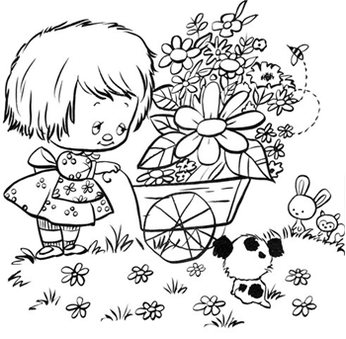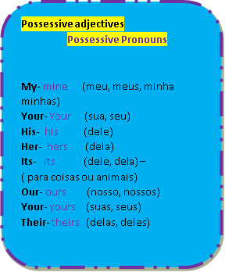

**1.Write his or her 2.Change to plural**

a.Mary has a car. a.Open your **book**.

____ car is blue. __________________________

b.Jane has a bike. b.Read your **letter**.

____bike is red. __________________________

c.Paul has a house. c.Your **pencil is** long.

____ house is new. __________________________

d.Fred has a book. d.Your **motorcycle is** new

____book is interesting. __________________________

e.Lucy has a friend. e.Your **teacher is** good.

_____ friend is John. ___________________________

**3.Answer the questions using possessive pronouns.**



www.acessaber.com.br

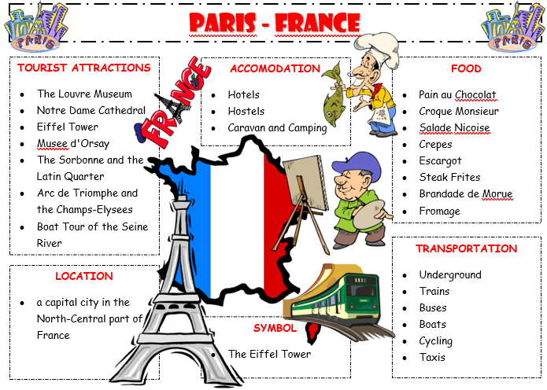

Write a short text describing Paris using the information above.

